LESSON 5: TRANSISTORS

SOLID STATE DEVICE
- Is an electronic component that relies on the movement of electrons through solid materials, such as semiconductors, rather than relying on vacuum or moving parts. Examples include transistors, diodes, and integrated circuits (ICs). These devices are compact, durable, energy-efficient, and form the backbone of modern electronics like smartphones, computers, and televisions.
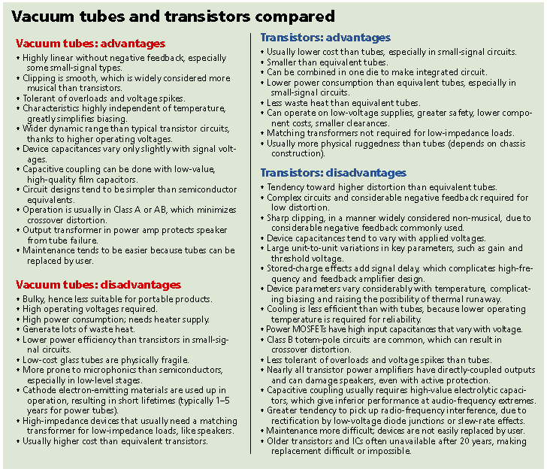

IN SHORT
VACUUM TUBES ARE: TRANSISTORS ARE:
- BIG - VERY SMALL
- HOT - NOT LIGHT BULD HEATED
- SLOW - FAST
- BROKE DOWN OFTEN - RELIABLE

TYPES OF TANSISTORS

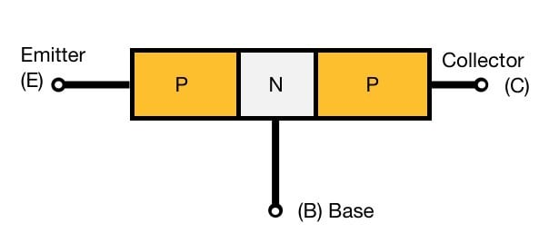
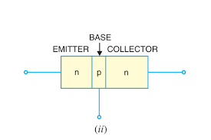

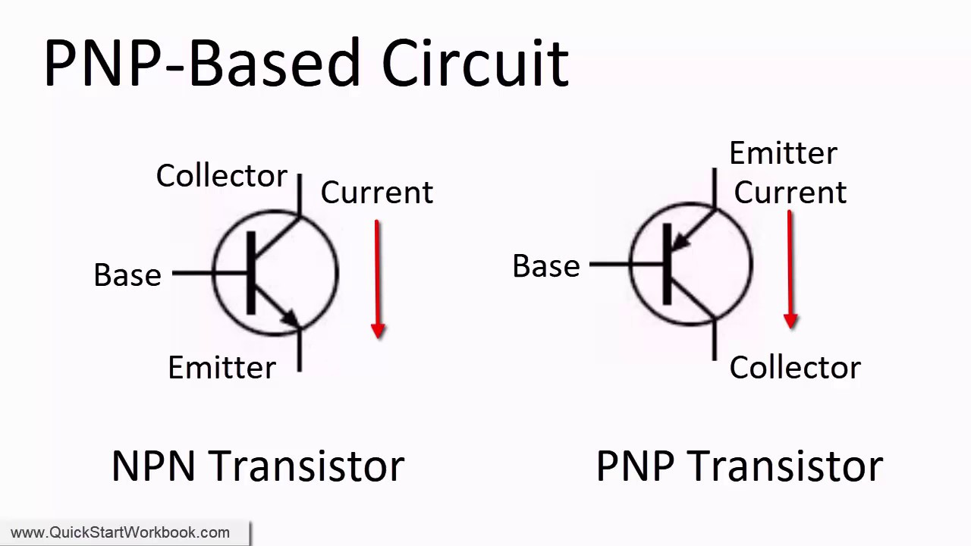

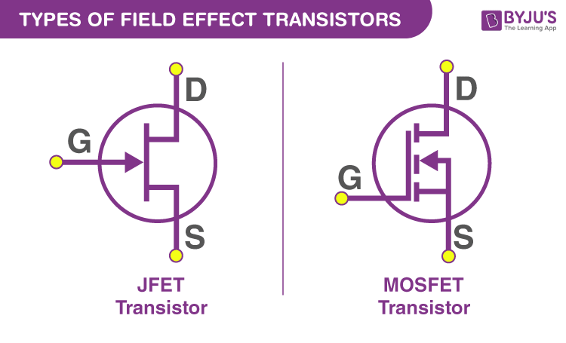

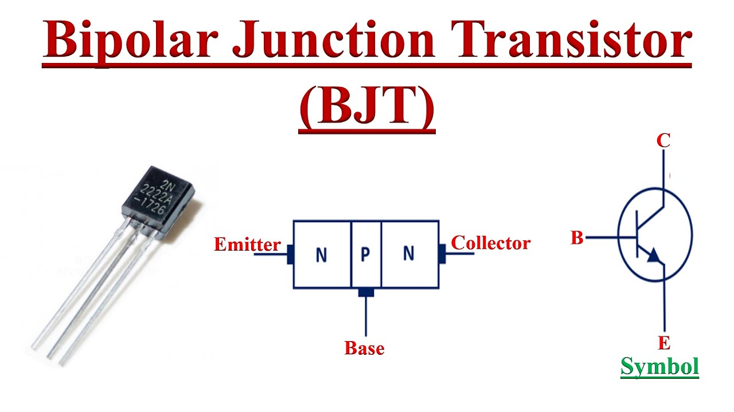

FLOW OF CURRENT
NPN AND PNP TRANSISTOR
